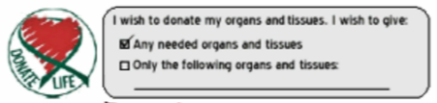

**Donor:** JENNIE

**Witness 1:**  Tyrion (Husband)

**Witness 2:**

**Date:** 10/11/2006 **Signature:** Jennie